**Reading and Reading Quiz Week 4**

**Summary Review of Electric Potential energy (U) and Electric Potential (V)**

In the reading quiz for week 3, we showed that the Coulomb force is conservative. As a result, its work between two points can be expressed in terms of a change of potential energy ():

We also introduced the concept of the change of electric potential to be the change of electric potential energy per unit charge.

* A charged object produces an electric field at any point in the space around it.
* A charge passing at a point feels a force **.**
* Between two points A and B in space, the fieldsets a change of electric potential .
* The charge moving between A and B experiences a change of potential energy

|  |
| --- |
| Change of **electric potential** Change of **electric potential energy** |
|  |

**Remark:** Because the force is conservative, we can pick any path to calculate the integral of E between two points!!

**Relating the electric field lines and the electric potential.**

**Moving along an E-line:**

|  |  |
| --- | --- |
| Figure 1-a | Figure 1-b |
|  |  |

Consider a region in space with and E-field represented by the field lines in Figure 1. Pick points A and B as shown, figure 1-a. We can calculate the change of electric potential between the points as:

Without doing the integral we can see that moving from A to B along the E-line, the element of path is parallel to at any point:

As a result, the integral is positive and the change of electric potential is negative:

Moving along an E-line, **in the same direction as the E-field, the electric potential decreases!!!**

Consider now the change of electric potential between points C and D in figure 1-b. The element of path is antiparallel to at any point:

As a result, the integral is negative and the change of electric potential is positive:

**Moving** along an E-line, **in the opposite direction as the E-field, the electric potential increases!!**

**Remarks:**

* Moving along an E-line, in the same direction as the E-field, the electric potential decreases!!
* Moving along an E-line, in the opposite direction as the E-field, the electric potential increases!!
* E-lines flow from a region of high electric potential to a region of low electric potential.

**Moving perpendicularly to the E-lines:**

|  |
| --- |
|  |
| Figure 2. The dotted line is perpendicular to the field at every point |

Starting at point A we move to point B along a line that is at every point perpendicular to the E-lines, the dotted line in figure 2. The change of electric potential between A and B:

At any point along this path, the element of path is perpendicular to :

As a result, the integral is zero:

There is no change of electric potential along this line. This is called an “**Equipotential Line**”. More generally, we define an “Equipotential Surface” to be a region in space where the electric potential is constant.

An **Equipotential Surface** is constituted by all the points in space where the electric potential is constant:

E field lines are perpendicular to equipotential surfaces. As a result, the E-filed has no components along the equipotential surface.

**Watch this video about Equipotentials:**

[**https://www.youtube.com/watch?v=VHyo8Y0OG9M**](https://www.youtube.com/watch?v=VHyo8Y0OG9M)

**Question 1:** A positive charge moves along an E-line in the same direction as the E-field, its potential energy:

* Increases
* Stays de same
* Decreases

**Question 2:** A positive charge moves along an E-line in the same direction as the E-field, the work done by the electric force

* Positive
* Zero
* Negative

**Question 3.**

A charge q is moving on an equipotential surface between points A and B, , the work done by the electric force on the charge is

**Question 4. Drawing equipotentials.**

1. Draw the electric field lines and the equipotential lines around a positive point charge Q located at the origin.
2. Draw the electric field lines and the equipotential lines for a dipole.

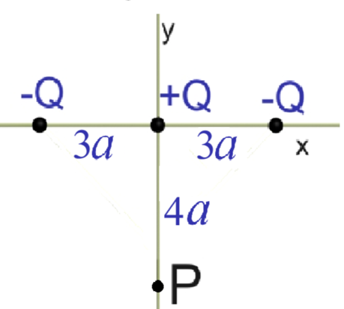**Question 5. The electric potential of a discrete distribution of charges**

Three point charges −*Q*, *+Q* , and −*Q* are located a distance 3*a* apart along the x axis. Point *P* is located on the ***negative*** *y*-axis a distance 4*a* from the origin (see sketch).

The figures below show possible field lines and equipotential surfaces for this problem.

Which figure is the correct field line representation for this problem?

Which figure is the correct equipotential representation for this problem?

